**Society of British Neurological Surgeons of UK and Ireland Caribbean Training Fellowship**

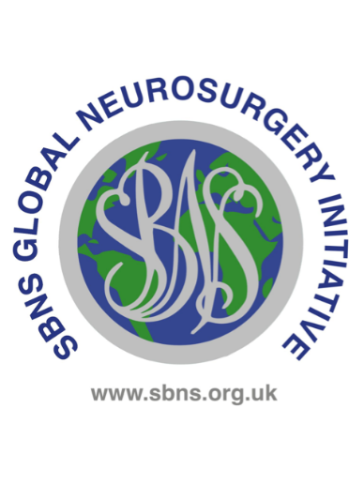The Society of British Neurosurgeons (SBNS) is inviting applications for the following fellowship

**Background**

Jamaica is the largest English-speaking country in the Caribbean. The history of medicine in Jamaica is intertwined with the UK. Until the 1940s, the majority of medical doctors in Jamaica were British expatriates, some Jamaican doctors who were trained in the UK and a small number of American trained doctors. There was no local training for medical doctors until the University of London established their University College in Mona, Jamaica in 1948 with the admission of three students to the Faculty of Medicine (the only faculty at the time). This later became the University of the West Indies (UWI), which has expanded significantly with the establishment of many faculties and campuses throughout the Caribbean. The medical faculty now has seven faculties across the Caribbean offering several undergraduate and post graduate programmes.

**Neurosurgery in Kingston, Jamaica**

There are currently 10 trained neurosurgeons in full-time hospital practice serving a population of three million. There are surgeons with special interests in paediatrics, skull-base, minimally invasive spine, vascular and endovascular surgery. Jamaican trainees are expected to be good general neurosurgeons in the first instance who then develop sub-specialty interests in endovascular surgery, oncology, paediatrics, complex spine and functional neurosurgery.

UWI training parallels the UK programme. In the first 2 years, the candidate is exposed to a range of surgical disciplines while being immersed in basic surgical sciences and thereafter commences specialist training in neurosurgery. As part of the training, candidates are required to undertake an overseas elective (one to two years) prior to completion of the programme.

**Clinical opportunities**

Jamaica’s population is 3 million. Neurosurgical units are present at the University Hospital of the West Indies, Kingston Public Hospital, Bustamante Hospital for Children and the Cornwall Regional Hospital. Trainees would have wide exposure to general neurosurgery and especially to trauma.

Trainees will have the opportunity to participate in 4 elective surgical (3 adult and 1 paediatric) lists per week. They will have a wide exposure to general neurosurgery including tumours, vascular, general and minimally invasive spine, skull-base and endoscopic surgery. There is a daily emergency list, the majority being trauma related (intracranial haematomas, cranial gun shot wounds, depressed skull fractures etc.).

There are academic sessions on Mondays, Wednesdays and on monthly Fridays. Morbidity and mortality audits are performed quarterly. Multiple disciplinary team meetings are undertaken in oncology. Quarterly meetings are held with the skull-base team (neurosurgery, ENT and maxillo-facial surgery).

**Research opportunities**

There are numerous opportunities for clinical research for motivated trainees. There is strong support to establish a Caribbean wide Neuro-trauma registry whilst research in cranial trauma, hydrocephalus, spinal dysraphism, CNS infection and cerebral tumours would all be highly encouraged. The global traumatic brain injury registry is also likely to be an available project.

**Accreditation**

A certificate of completion endorsed by SBNS will be provided on receipt of a suitable reference from trainers and a short report on the fellowship that can be used to help recruit future candidates.

**Funding and salary**

This post is unfunded and there is no salary. Applicants are encouraged to seek alternative sources of funding.

**Selection**

Please also see the selection criteria document for shortlisting criteria

* Applicants must be a member of the SBNS and have been continuously for at least 2 years.
* Applicants must be at least ST3 level, or equivalent
* Applicants with an NTN must have prospective approval from their local deanery or School of Surgery. (ie Health Education England, NHS Education for Scotland or Health Education and Improvement Wales, Royal College of Surgeons, Ireland) **and** have the support of their Training Programme Director **and** an outcome 1 at their most recent ARCP.

The closing date for applications is Wednesday 31st January 2025.

Interviews will be held in London on Wednesday 5th February 2025.

To apply, please email the following documents to Alix Gordon. [Admin2@sbns.org.uk](mailto:Admin2@sbns.org.uk)

* + - Application form
    - Training Programme Director reference form (NTNs only). The same form can be used if you also decide to apply for the Diana and Alan Karter awards.
    - Logbook SAC indicative report
    - Independent reference from a Neurosurgical trainer other than the Training Programme Director
    - Confirmation that a period out of programme has been considered and supported (or at least applied for) by the local deanery (NTNs only)

**Additional information**

Successful applicants are required to submit a short report of their visit within two months of return.

Applicants must inform the SBNS Global Neurological Surgery Committee of any change in their circumstances which will prevent them from completing their overseas visit.

The SBNS global neurosurgery initiative has organised this fellowship in good faith but accepts no liability for any costs or injuries incurred.

Revised Sep 2024