APPLICATION FOR SBNS CPD APPROVAL

The Society of British Neurological Surgeons will recognise courses that meet the Academy of Royal Medical Colleges CPD Standards.

Please complete the following sections of the form referring to the guidance ‘Standards and Criteria for CPD Activities – A Framework for Accreditation’, and providing evidence to support your answers where applicable.
Attendees will be able to claim 1 CPD point for every hour of the course, excluding refreshment breaks and social event, attended.
A valuation form should and Certificate of attendance should be issued to all attendees (see attached sample)

Organiser's Details

Activity Organiser

Professional Address

Address for correspondence

Invoicing address, if different

Contact name and details of person responsible for application

Type of Organisation  (tick one box) | Commercial organisation  Non-commercial/non-profit organisation
Telephone number

Email

Website

If you have applied for accreditation previously, please quote the accreditation reference number

Activity Details

Title of activity

Date of activity

Venue / webpage URL

Attendance Fee (s)

Number of attendees expected

Details of programme structure, content and timetabling. Please tick to confirm finalised programme is attached

Educational Content of Activity

What is the target audience?

What are the key learning aims?

What delivery methods are being used?

Provide the name(s) and title[s] of presenter(s). Provide evidence to demonstrate that they have the expertise to deliver the educational content of the activity.

Sponsorship and Conflict of Interest

Tick this box to confirm that there is no conflict of interest on the part of the sponsor or other
commercial interest, OR where this is the case, full details are provided below

Tick this box to confirm that the educational content is not biased by a sponsor or other
commercial interest, OR where this is the case, full details are provided below

Please state the form in which the sponsorship has been provided – this should be in the form of an educational grant.

Evaluation, review and feedback

What process will be used to evaluate the quality of teaching and learning provided? Attach any feedback/evaluation form used. (see sample below)

What processes are in place to encourage self-reflective learning and relating learning to practice?

Confirmation of Application

Tick this box to confirm that the information provided in this form is accurate and that the
responses given represent those of the applicant organisation.

Name

Job Title

Date

MEETING EVALUATION FORM
Please complete this questionnaire in order that we can gain valuable information on how to improve future events.

Event Organiser: Mr P Kirkpatrick, Consultant Neurosurgeon, Addenbrookes Hospital, Cambridge

Your Name (Optional): Grade:

RATING SYSTEM: strongly agree 5....4....3....2....1 strongly disagree
 | 5 |  | 4 |  | 3 |  | 2 |  | 1
The meeting was relevant to the organisation of my unit.

This meeting will change how service is delivered in my unit.
The meeting avoided all undue commercial bias.

The abstract selection was representative of relevant topics.
The speakers communicated effectively and the information was well presented.
The meeting was very well structured.

There was sufficient time available for discussion.

I learnt a great deal from this event.

The organisation of the meeting was efficient.

The venue met all of the meeting requirements.

The catering was of a good standard.

The social events were good value for money and enjoyable.
COMMENTS:

Thank you for taking the time to complete this form
Please hand in to reception on your way out

Certificate of Attendance

Hosted by Addenbrookes Hospital, Cambridge

This is to Certify

………………………..

has attended the above meeting.
Attendance at this meeting offers a maximum of one Continued Professional Development point per hour of the conference attended – excluding refreshment breaks and social events.

I confirm that I attended the Society of British Neurological Surgeons Spring Meeting for a total of ____ hours.

Signature:_______________________________

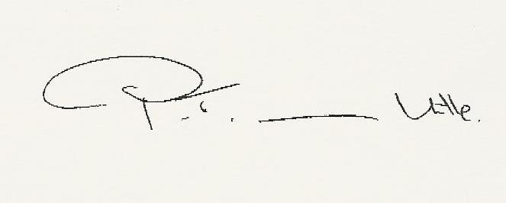

Philip van Hille

President, SBNS

