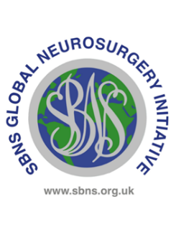

**UK and Ireland Neurosurgical Trainees Award**

**Training Programme Director Form**

Dear TPD,

Your trainee is applying to the SBNS Global Neurological Surgery Committee for a travel grant to support a period of study in a low or low middle income country. We are grateful to you for completing this form.

|  |  |
| --- | --- |
| Trainee’s name | Click or tap here to enter text. |
| ST training year at time of travel | Click or tap here to enter text. |

Please confirm all the statements below

|  |  |
| --- | --- |
|  | I confirm that this trainee is a run through trainee with a National Training Number |
|  | I confirm that this trainee achieved an outcome 1 at their most recent ARCP |
|  | I confirm that this trainee is not currently under investigation by the GMC or hospital trust |
|  | I confirm that this trainee has been granted leave by the deanery (usually but not necessarily as an OOPE) to undertake this time out of programme |
|  | I confirm that I believe it will be beneficial to this trainee to undertake time out of programme and I support this application |

**Any additional information?**

|  |
| --- |
| Click or tap here to enter text. |

|  |  |  |
| --- | --- | --- |
| **Your name** | **Date** | **Signature** |
| Click or tap here to enter text. | Click or tap to enter a date. |  |