**Society of British Neurological Surgeons of UK and Ireland Nepal Training Fellowship**

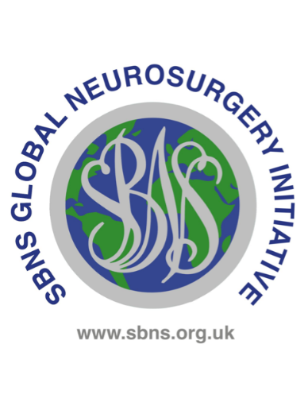The Society of British Neurosurgeons (SBNS) is inviting applications for the following fellowship

**Background**

Nepal, situated in the southern Himalayan mountains between India and Tibet is 500km East to West and 150km North to South. Nepal is recognised by the UN as one of the 45 least developed countries in the world, it has a population of just over 30 million, more than half of Nepalis are below the age of 35.

Neurosurgical training in Nepal is a 3 year programme that is available only to those that have already completed 3 years residency in general surgery. During this period, trainees operate on patients under supervision. There are 11 places available annually in seven Neurosurgical units.1

The Nepalese Society of Neurosurgeons (NESON) was formed in 2008 and now has a membership of around 100 members. Neurosurgical training centres are situated in Chitwan, Pokhara, Kathmandu (three centres), Biratnagar and Janakpur. 1

**Neurosurgery in NAMS Bir Hospital, Kathmandu**

NAMS Bir Hospital is a large training centre situated in the centre of Kathmandu. The neurosurgery service is provided by three units; general neurosurgery, skull base and neuroendoscopy and neurovascular diseases. There is a professor, two associate professors, two assistant professors and six residents.

**Clinical opportunities**

U.K. trainees will be expected to have the same duties as residents, this will include ward rounds, outpatients, academic activities, on call, emergency and elective operating.

**Research opportunities**

There are numerous opportunities for clinical research for motivated trainees. The global traumatic brain injury registry is also likely to be an available project.

**Accreditation**

A certificate of completion endorsed by SBNS will be provided on receipt of a suitable reference from trainers and a short report on the fellowship that can be used to help recruit future candidates.

**Funding and salary**

This post is unfunded and there is no salary. Applicants are encouraged to seek alternative sources of funding.

**Selection**

Please also see the selection criteria document for shortlisting criteria

* Applicants must be a member of the SBNS and have been continuously for at least 2 years.
* Applicants must be at least ST3 level, or equivalent
* Applicants with an NTN must have prospective approval from their local deanery or School of Surgery. (ie Health Education England, NHS Education for Scotland or Health Education and Improvement Wales, Royal College of Surgeons, Ireland) **and** have the support of their Training Programme Director **and** an outcome 1 at their most recent ARCP.

The closing date for applications is Wednesday 31st January 2025.

Interviews will be held in London on Wednesday 5th February 2025.

To apply, please email the following documents to Alix Gordon. [Admin2@sbns.org.uk](mailto:Admin2@sbns.org.uk)

* + - Application form
    - Training Programme Director reference form (NTNs only). The same form can be used if you also decide to apply for the Diana and Alan Karter awards.
    - Logbook SAC indicative report
    - Independent reference from a Neurosurgical trainer other than the Training Programme Director
    - Confirmation that a period out of programme has been considered and supported (or at least applied for) by the local deanery (NTNs only)

**Additional information**

Successful applicants are required to submit a short report of their visit within two months of return.

Applicants must inform the SBNS Global Neurological Surgery Committee of any change in their circumstances which will prevent them from completing their overseas visit.

The SBNS global neurosurgery initiative has organised this fellowship in good faith but accepts no liability for any costs or injuries incurred.

**References**

1. Chaurasia B et al. Neurosurgery training in Nepal: then and now Front. Surg., Neurosurgery section, (10) June 2023 https://doi.org/10.3389/fsurg.2023.1211722

ST Sep 2025